How Can We Save Syria?

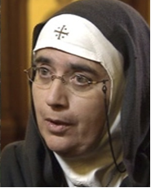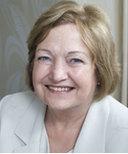
Mother Agnes-Mariam of the Cross: Russia used this prominent Syrian-based nun’s testimony on the Ghouta chemical gas outrage to stop the USA bombing Damascus. At great personal risk, she personally brokered a cease-fire between rebels and Syrian troops in Moadamiya which helped save the lives of over two thousand civilians. Further information on this amazing nun may be obtained by going to the Archbishop Cranmer blog here http://bit.ly/HEf4i5 and by following the links from there.
Dr Halla Diyab: Dr Diyab is an award-winning British-based Syrian TV screen-writer, film director, women’s rights advocate and independent-minded commentator on the tragedy of her native Syria. Her refreshingly forthright views on how the Syrian people may still be rescued from the hell they have had imposed on them offer much-need light at the end of Syria’s very dark tunnel. Further information on this amazing daughter of Syria is at: https://twitter.com/DrHallaDiyab or www.libertymediaproductions.co.uk
Mairèad Maguire: Since being awarded the 1976 Nobel Peace Prize, Mairèad Maguire has dedicated her life to the pursuit of peace in the world’s trouble-spots, including Myanmar, Gaza, Iraq, Afghanistan and Syria, to where she led a Mussalaha fact-finding peace team to Damascus at Easter 2013. Mairèad Maguire is one of the co-founders of the Nobel Women's Initiative, along with fellow Peace Prize laureates Shirin Ebadi, Wangari Maathai, Jody Williams, and Rigoberta Menchu Tum.
VENUE: Maharashtra Mandal London: http://www.mmlondon.co.uk/
TIME: 1pm-5pm, Sunday 24 November 2013
Place: 306 Dollis Hill Ln, London NW2 6HH
Directions: Buses 32, 316 from Kilburn station, bus 266 from Willsden Green station. http://tinyurl.com/AgnesSunday for more directions.
How Can We Save Syria?

